The World Cup Promotions: The Story So Far
What UK operators really did with promotion in the opening weeks of the tournament
By Mitch Vidler, CCO, Jurnii

Jurnii 360 tracks what UK operators are doing with price and promotion, week on week. Across the World Cup window of 31 May to 30 June, with the tournament starting on 11 June, the market ran 125 promotions genuinely built around the event, across 17 operators. That count strips out evergreen mechanics that only mention the World Cup in passing, and it is the basis for everything below.

Retention, not a land grab
The single clearest finding is that this is a retention exercise. Of the 125 activations, 116 target existing customers and just eight target new ones. For an event routinely described as the acquisition moment of the cycle, almost nobody is using it that way. Operators are using the World Cup to re-engage the customers they already hold, give them a reason to return match after match, and move them between products.

Existing versus new customer targeting across all 125 activations. Source: Jurnii 360.

Three types of promotion, not one campaign
That activity is not a single campaign repeated in three places. It splits into three types of promotion, each built from a different set of mechanics. The sportsbook layer is built from price boosts, free bets, money back and bet-and-get. The casino cross-sell layer is built almost entirely from prize giveaways. The free-to-play layer is built from prediction games. An operator's World Cup strategy is really a decision about which of these it leans on, and how heavily.
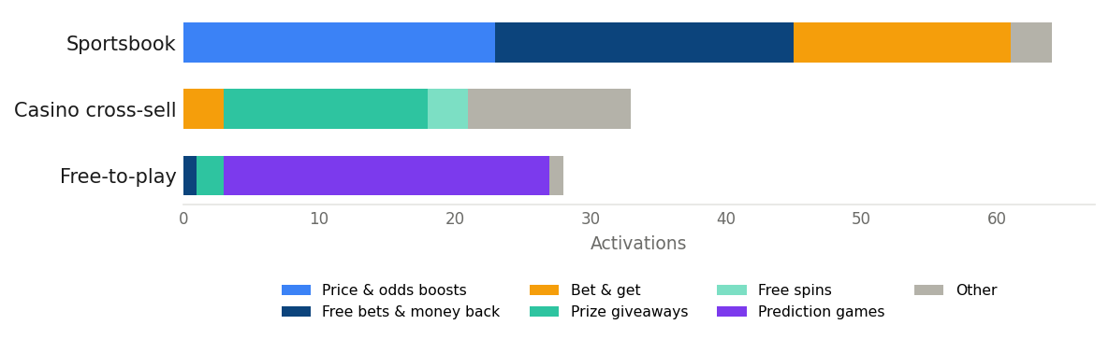
Mechanic mix by layer. Source: Jurnii 360, 31 May to 30 June 2026.

The footprint, and the fixture machine
Sportsbook is the largest layer at 64 of the 125 activations, and it is built match by match rather than tournament-wide. Just over half of it is tied to a specific fixture, so Sky Bet, BOYLE Sports and Coral issue a fresh money-back or booster for each England game instead of one standing offer. That keeps the brand in front of the customer on a rolling basis and lets the offer track the fixture, at a heavier operational cost. Coral runs the most templated version, an identically worded money-back offer cloned per match.
The volume leaders are therefore not the brands with the richest single offer. They are the brands running the most separate activations, and the top three account for more than a third of all the activity in the window.
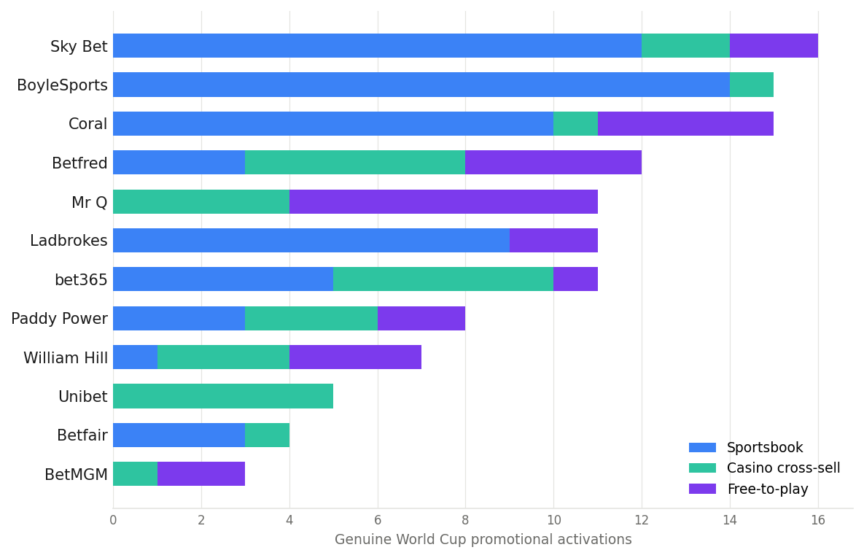
World Cup promotional activations per operator, by layer. Source: Jurnii 360.

An evergreen floor and a tournament wave
The timing splits cleanly. Forty-three of the activations carry no dates at all, the recurring casino and free-to-play campaigns that simply sit live across the window. Of the dated offers, activity builds into the tournament, with thirty live before kickoff against forty-nine from kickoff onward. BoyleSports is the clearest pre-event mover, running a dated countdown series in the build-up. The shape is a steady evergreen floor with a sportsbook wave that comes alive at kick-off and then runs fixture by fixture.
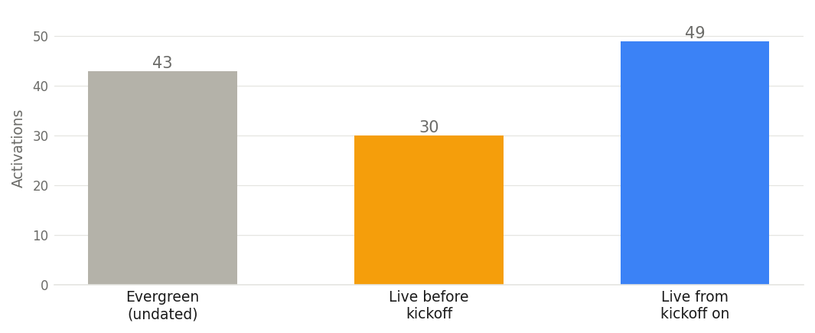
When activations went live, relative to the 11 June kickoff. Source: Jurnii 360.

Two ways of paying
Look at how the value is expressed and two different logics sit side by side. The sportsbook layer deals in small, certain amounts, a one pound free bet, five pounds back if a bet builder loses, a 25 per cent winnings boost. The casino and free-to-play layers deal in large, pooled headline numbers, a million pounds on Road to Glory, £750,000 on Cash Cup, £25,000 prize drops, shared across a field rather than paid to any one player. Reading generosity off the headline would mislead badly, because the big number is a banner and its expected value per player is low.
The reward currency confirms the direction. Free bets appear in 50 of the activations and cash in 44, while casino spins appear in only 18. Even though a third of the footprint is delivered through casino and free-to-play wrappers, the reward inside most of those wrappers is free bets or cash, which routes value back toward the sportsbook. Genuinely casino-direction value is thin, so the cross-vertical bridge runs mostly one way.
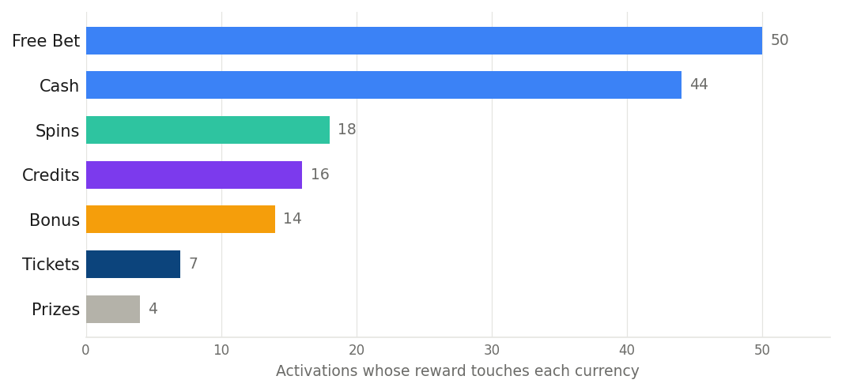
Reward currency across all activations. Offers can pay in more than one currency. Source: Jurnii 360.

How much is really shared product
A word of caution for anyone reading the operator counts as a creativity league table. A meaningful slice of what looks like distinct strategy is the same syndicated product skinned per brand. Road to Glory appears at five operators and World Football Predictor at three, so at least eight of the 125 activations are two supplier products sold to multiple books rather than independent ideas. Strip those out and the genuinely brand-built work is narrower than the raw count suggests.

In focus: Betfred turns goals into free spins
The most interesting design in the window is not a giveaway, it is a small set of casino offers that wire the reward directly to the match. The clearest example is Betfred's World Cup Free Spins for Goals. Customers opt in and stake ten pounds or more on slots, then earn three free spins for every goal Harry Kane or John McGinn scores across the 23rd and 24th of June, up to a maximum of thirty. The spins are credited at half past five on the 25th and can only be played on one slot, King Kong Cashpots.
It is unusual because the reward is not a fixed bonus dressed in football colours. It is a variable casino payout whose size is set by a live football outcome. To qualify a customer has to be playing slots, so the casino activity is captured up front, but the payout only fires if specific players score, which keeps the cost contingent and capped. It is the rare promotion that makes a slots player care about a particular striker, and gives a match-watcher a reason to be in the casino.
Three design choices stand out. It is player-specific rather than fixture-specific, anchoring it to the two names a UK audience is actually watching. The eligible slot is a generic title rather than a football-themed one, so the football lives entirely in the trigger. And the spins land two days after the matches, which manufactures a return visit to collect them.
BetMGM ran the same idea differently. Its More Goals, More Spins gave five free spins instantly plus more based on the total number of goals in England against Panama, tiered at five, ten or fifteen, and crucially it required the qualifying slots stake before kickoff. Where Betfred rewards after the fact off two named players, BetMGM uses the football to pull the casino stake in early off a single fixture, and pairs it with a football-themed slot. The chart below shows how each scales.
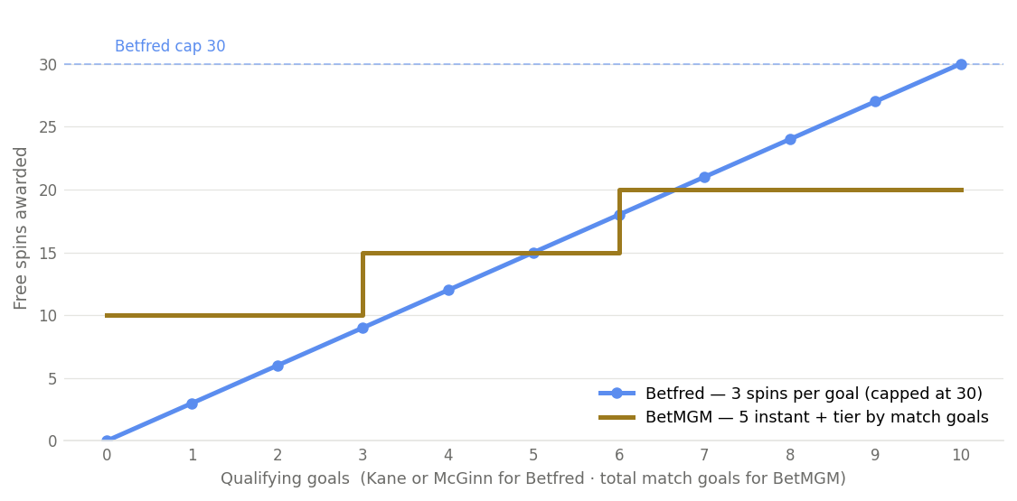
Free spins awarded as goals add up. Betfred counts goals by Kane or McGinn; BetMGM counts total goals in one match and adds five instant spins. Source: Jurnii 360.
Set against the prize-drop giveaways that make up most of the casino layer, both of these are doing something more interesting. They are not redirecting attention with a big banner number, they are fusing the two products so that the match outcome becomes the casino variable. It is also a low-risk design for the operator, because the stake is captured regardless and the payout only fires if the goals do. If this mechanic spreads, it is the clearest sign of operators treating the tournament as one cross-vertical event rather than two separate promotional calendars.

What it adds up to
The pattern through the opening weeks is steady. Operators are not using the World Cup to win new customers, they are using it to keep the ones they already have busy across more of their products. The casino and free-to-play layers are doing the cross-sell work, but mostly as a way to feed the sportsbook rather than the other way round, and most of the value on offer still points back at the book.
What is worth watching is the knockout stage. Fewer matches, higher profile, and the first signs, in Betfred and BetMGM, of operators wiring the casino reward straight to the match. If that mechanic spreads as the stakes rise, it is the clearest move yet toward treating the tournament as one event across the whole product, rather than two promotional calendars running side by side.

